

Are you interested in being part of our 2027 Tour - September 18-19, 2027?

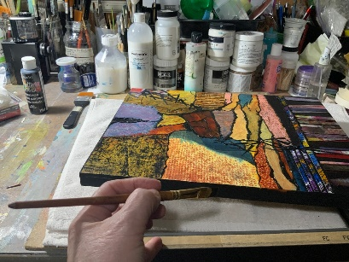
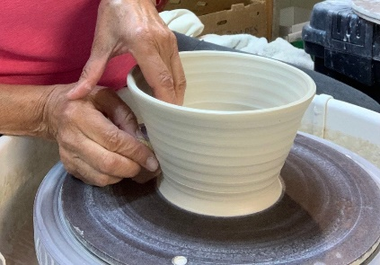

Info and Application Form can be found on our website at

www.hartetrailstudiotour/about

Questions? Email us at htstudiotour@gmail.com


Take a picture of this info
sheet with your phone or scan the QR code

